Project: website

UA 2022-2023

# The project

You are requested to design a fully responsive website. See details below.

Please fill in the requested information and upload on Teams.

## Personal info

|  |  |
| --- | --- |
|  | 202311908 / Bahaa Zaakie / 202311908@ua.edu.lb |

## Project Description

|  |  |
| --- | --- |
|  | The website I’m creating will be about our family-owned pastry business, sahteen. Our business is still relatively new, I want to create a website that’ll share our vision for the brand, share its story, how it came about, and be a bridge to connect with others who wish to know more about the brand and engage with us.  It will consist of at least 4 pages: the first one is a landing page that contains pictures and some text, the second one is a pastry menu, the third page is a dessert menu, and the last one will be a page that contains information about the business and our mission. |

# Website layout

The website should be fully responsive adapted to all screen sizes (mobile, tablet, desktop). Below is a simple example.

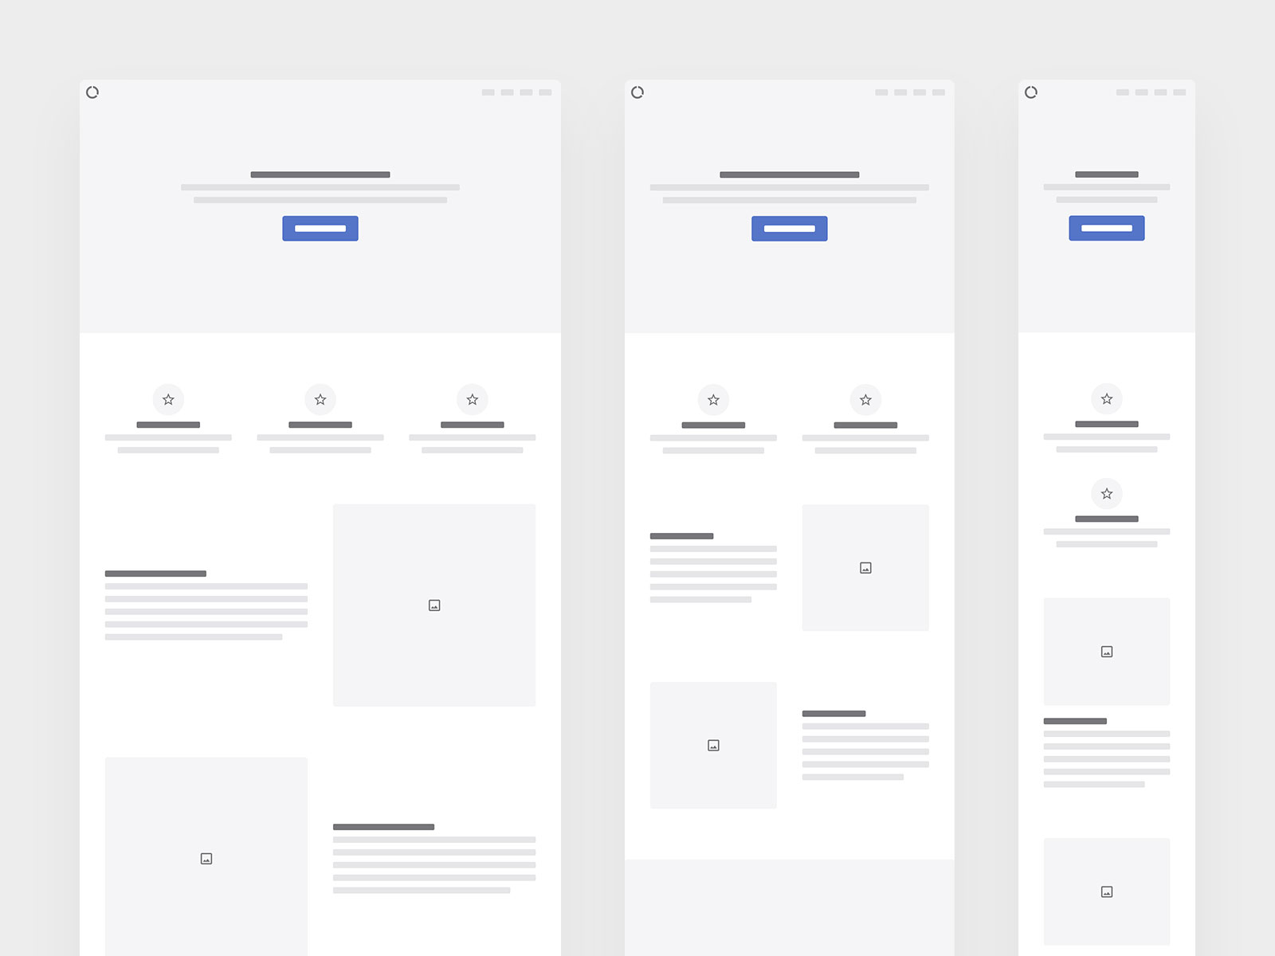

# Site content and structure

1. The project should contain up to 5 pages.
2. All pages should contain a header that has the title/logo that you should create using Adobe Illustrator.
3. All pages should contain a menu/dropdown menu that contains links towards the web pages.
4. All pages should contain a footer that contains copyright information with social media links.
5. A contact page should be created containing a form of submission and with HTML5/JavaScript validation.
6. At least one page should contain links to download related files (example: file1.pdf, sound.mp3, etc.)
7. Add a couple of feature/elements from Bootstrap.
8. The creativity, the user experience and the display of content adds value to your project.

# Folders structure

A correct folder structure should be followed during the development of the website. All names should be in lowercase and written without spaces.

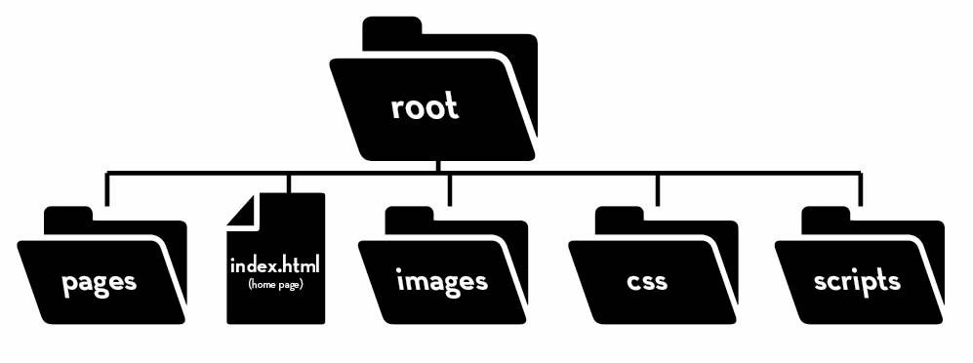

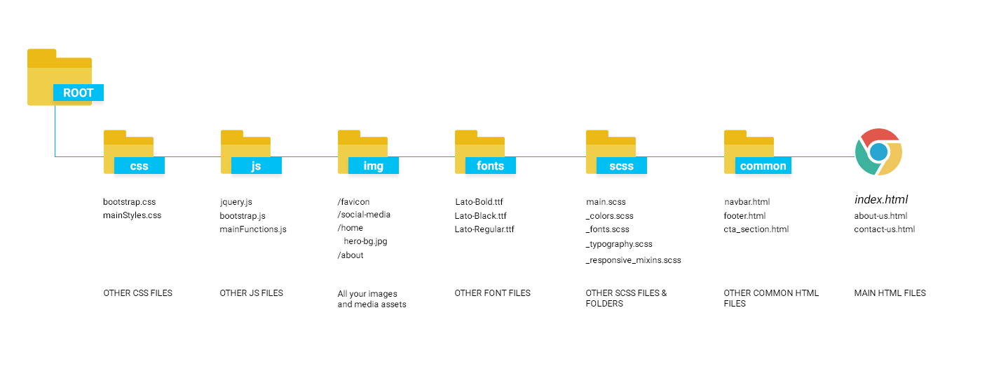

# EVALUATION

**20%:** Logo design, website folders structures, files naming, optimization of images  
**50%:** Overall website design, variety in the content layout in the pages, proper use of HTML & CSS  
**25%:** Responsive design on tablets and mobile **5%:** Use of Bootstrap

# Project delivery

Compress your project into a zip file entitled *WD_Firstname_Lastname*.zip and then uploaded on Teams or on wetransfer.com and share the link via Teams. The presentation of the project will take place in the last 2 sessions.

*Good Luck!*